impact of selected POST-MINING and post-metallurgicaldumps on air pollution
Václav Dombek, Lucie Gembalová, Tomáš Tomšej, Dalibor Matýsek, Leszek Drobek, Zbygniew Bzowski, Lukáš Ženatý, Radim Seibert

INTRODUCTION
The aim of the work consisted in quantifying the size of emissions of heavy metals and polycyclic aromatic hydrocarbons (PAHs) as well as their impact on air quality in the Ostrava-Karvina region as a result of mining and metallurgical activities (dumps). The material stored on the heaps undergo very often chemical and mechanical changes, some of them are even initiated by burning practices (e.g. Heřmanice heap). Emitted and deposited dust particles get into the atmosphere via winds, traffic and transportation as well as by mining the heap waste. These activities may contribute to the deterioration of air quality in the neighbouring areas (airborne dust, carcinogens) and has not been explored yet. The current issue of air quality in the region was the subject of the project "Air Quality Information System in the Polish-Czech border area in the Moravian and Silesian Region" (Air Silesia) [1], the question resuspension of dust particles from waste piles and around industrial enterprises but unaddressed.
By this time, the exploration works in the area of ​​dumping sites associated with air pollution have primarily been focused on the issue of suspended particles, in particular as part of the EIA (Environmental Impact Assessment) projects addressing the use of materials stored in the dumps for construction purposes. These works were carried out on a small number of sites; however, they were not comprehensive studies, so it is impossible to derive the overall impact of dumps on the air quality.
The emissions of gaseous substances from thermally active dumps represent the second area linked to air quality, on which the surveys have been focused so far. However, the results obtained are burdened with unacceptably high uncertainties that preclude their use for draft regulations concerning further exploitation of dumps.
The lack of information on the contents of heavy metals and polycyclic aromatic hydrocarbons in the emissions into the atmosphere is the main drawback of recent ratings. Considering the smaller (zero) explorability, this project focused on air pollution impacts of dumps associated with the emissions of heavy metals and polycyclic aromatic hydrocarbons.
Although the content of the mineral phases is considered relatively harmless to the environment [2], an integral part of the research was to determine precisely the mineral phases using X-ray diffraction [3]. All analyses were however focused on PM10, which in recent years through the center of greatest interest [4-6]
Own research was performed within the project CZ.3.22/1.2.00/12.03398 Evaluation of concentrations of PAHs and heavy metals on the surface of dumps and nearby industrial enterprises funded through the Operational Programme Czech Republic – Poland 2007-2013. The Faculty of Mining and Geology at the VŠB - Technical University of Ostrava (here and after referred to as VŠB-TUO), namely the Institute of Clean Technologies for Mining and Utilization of Raw Materials for Energy Use (here and after ICT), was the project holder, and the Central Mining Institute in Katowice (here and after as GIG) a foreign partner.

SITE SELECTION
For the entire project, 10 sites on the Czech side and 10 sites on the Polish side of the border were selected. The pilot study was then conducted at one site in the Czech Republic and one in Poland, specifically on the dumps of the ČSM Mine (Fig. 1) and “Szotkówka I” of KWK “Jas-Mos” (Fig. 3).
- ČSM Mine dump
The ČSM Mine dump where the mine material, namely the washery dirt of the dense liquid “washing plant” is stored, is administered by the company OKD, a.s. For the study, samples were collected from 18 sampling points (Fig. 2).
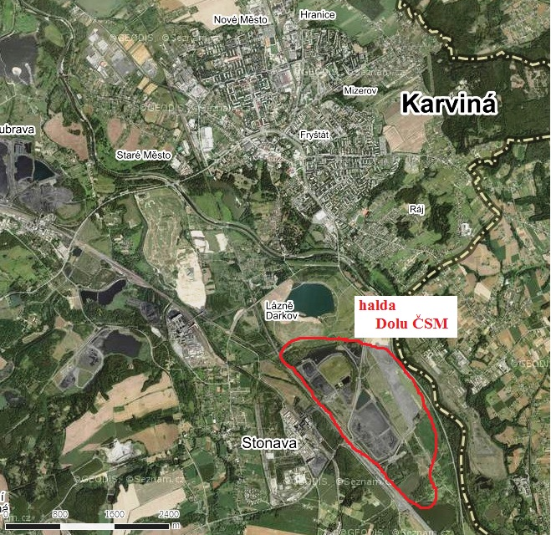
Fig. 1 . Localization of ČSM Mine dump

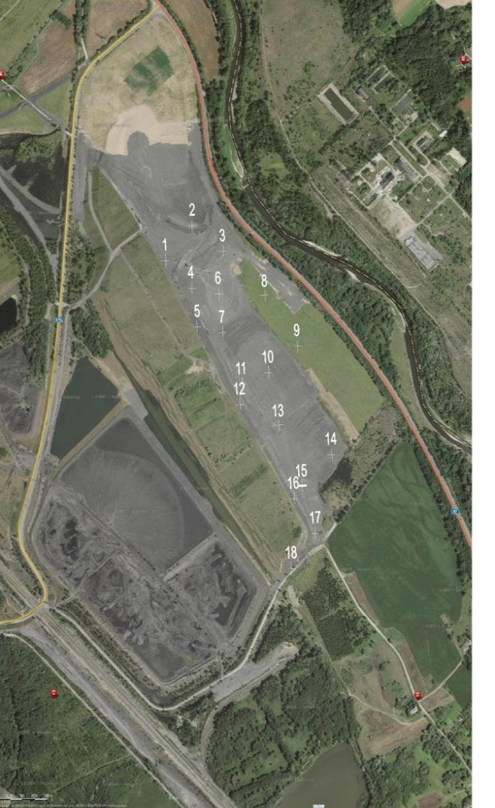
Fig. 2 Locatization of sampling points on the ČSM Mine dump.

- “Szotkówka I” of KWK “Jas-Mos”
The “Szotkówka I” dump is administered by the company KWK “Jas-Mos”. For the study, samples from 16 sampling points were collected (Fig. 4).

Fig. 3 Localization of the “Szotkówka I” dump
Fig. 4 Locatizaon of sampling points on “Szotkówka I” dump

METHODOLOGY
Chemical composition of both inorganic and organic phases as well as mineralogical description of the dump surface layer was conducted on both dumps. The subsequent evaluation of the data aimed at determining the size and composition of potential emissions of unhealthy particles and the circumstances of their occurrence. By modelling techniques, it was then possible to determine the impact of the investigated dumps on air quality. This is important for decision about further use of the areas for land reclamation, mining or other purposes.
Both partners, the VŠB-TUO and GIG Katowice dispose of investigator teams, having many years of experience and well-equipped with modern laboratories [7].

- Sampling methodology
The applied sampling methodology was based on the US EPA AP-42 standard detailed in Appendix C.1[8].
One representative sample (RS) was obtained from 6 sub-samples (primary), each collected from the area of ​​1 m² at a maximum depth of 2.5 cm. Next, RS was adjusted by the following successive steps:
- From the RS collected from 1 point (12-25 kg), a laboratory sample weighing about 5 kg was prepared in the laboratory.
- From the laboratory sample was obtained by sieving first fraction PM200, then fractions PM40Using centrifuges have been further from the PM 40 fraction obtained PM10 which was further used for the determination of heavy metals and PAHs.

- Methods of analysis
  - Determination of heavy metals
The content of metals (As, Cd, Cr, Cu, Ni, Pb, V, Zn) in the PM10 particulate matter was determined by ICP-OES, after total digestion by aqua regia.

  - Determination of polycyclic aromatic hydrocarbons (PAHs)
After the extraction of the PM₁₀ particulate matter on ASE (Accelerated Solvent Extraction) and purification on columns using SPE (solid-phase extraction), the content of 16 representatives of PAHs (according to U.S.EPA – naphthalene, acenaphthene, fluorene, phenanthrene, anthracene, fluoranthene, pyrene, benzo(a)anthracene, chrysene, benzo(b)fluoranthene, benzo(k)fluoranthene, benzo(a)pyrene, dibenz(a, h)anthracene, benzo(g, h, i)perylene, indeno(1,2,3-cd)pyrene) was determined on a gas chromatograph with mass-selective detection (at ICT Czech Republic), or using the high performance liquid chromatography (HPLC) with a fluorescence-based detector (in GIG Katowice laboratories, Poland).

  - Mineralogical analysis
The mineralogical analysis on both sites were performed on the X-ray diffractometer from Bruker.

- Modelling
The aim of mathematical modelling consisted in evaluating the impact of emissions of heavy metals and polycyclic aromatic hydrocarbons generated by dumps on air quality.
Data preparation and modelling were performed as follows:
- Processing the results of the laboratory analyses of the samples – check for completeness of the sample set and applied units of concentrations, formatting the values ​​below the detection limits for data processing,
- Connection of geographical coordinates to the results of laboratory analyses; unification of data format; transformation from the WGS84 projection to S-JTSK,
- Spatial allocation of the results to sub-section of the dumps,
- Calculation of emissions from various parts of the dump,
- Preparation of additional data and filling the model with input data (reference points and wind roses),
- Calculation of air pollution contributions of the substances evaluated using the SYMOS7 model,
- Processing the calculated contributions to air pollution and their presentation in tabular form,

The methodology provided in US EPA AP-42 Section 11.9 Western Surface Coal Mining [9] was used for calculating the average annual emissions of suspended particles used as input into the modelling. The average annual mass flow of PM = 850 kg/ha/year.
Taking into consideration that the emission (resuspension) occurs as from a certain wind speed, the emission distribution of suspended particles during the year was calculated based on the methodology provided in US EPA AP 42 Section 13.2.5 Industrial Wind Erosion [10].
The approach for considering frost days was taken from the methodology provided in the CHMI VaV/740/2/02 project, DP 2: 2 Considering the Particles Resuspension from the Earth's Surface [11].
The actual model calculation of the emission spread for both sites was made using the SYMOS’97 software. The software evaluates air pollution contribution to the average annual concentrations under the mass flow, wind direction, air stability and frequency, and that for the wind class 11 and 20 m/s. The total air pollution contribution to the average annual concentrations was then evaluated as the sum of contributions under the two wind speeds. Then the calculation of the highest 24-hour PM₁₀ values was performed.
The climate data (wind roses) required for modelling using SYMOS’97 were delivered by the Czech Hydrometeorological Institute (here and after referred to as ČHMI) in Ostrava-Poruba.

RESULTS
For both sites, the total air pollution contribution to the average annual concentrations of suspended particulate matter PM₁₀ (µg/m³) was calculated.
With regard to the findings of maximum potential negative impacts of dust emissions from the dump was modeled total air pollution contribution to the average annual concentrations of the representative of PAHs - benzo(a)pyrene ( referred to as B[a]P). It has verified with respect to the concentration in the surface layer heaps of potential effects on the health of the surrounding population and at the same time it is a pollutant to set the limit. . In the case of heavy metals, arsenic (As) was selected due to toxicity and the concentration on the dump surface. Referring to laboratory certified concentrations on the surface of the dumps, other representatives of these groups of pollutants have significantly less potential effects on health and air pollution situation.
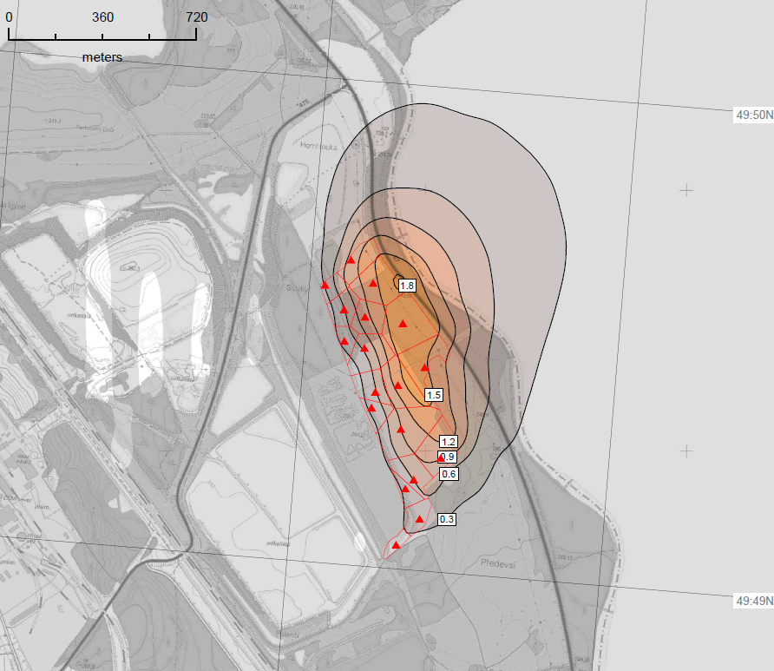
Fig. 5 ČSM Mine dump.
Total air pollution contribution to average annual PM₁₀ concentrations (µg/m³)
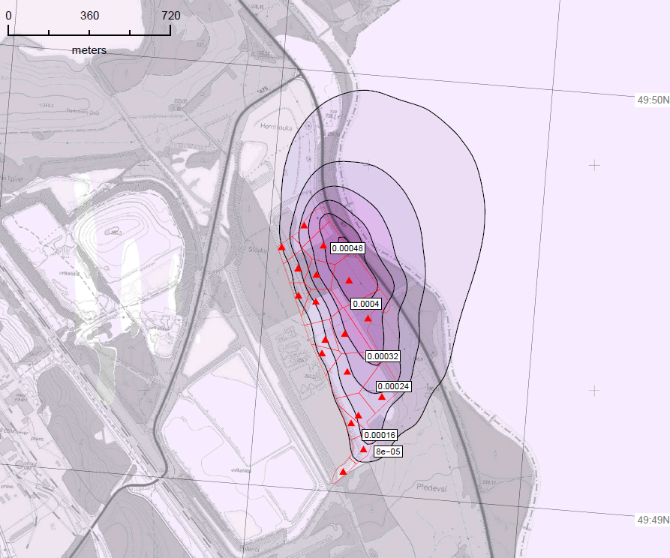
Fig. 6 ČSM Mine dump.
Total air pollution contribution to average annual concentrations of B[a]P (ng/m³)
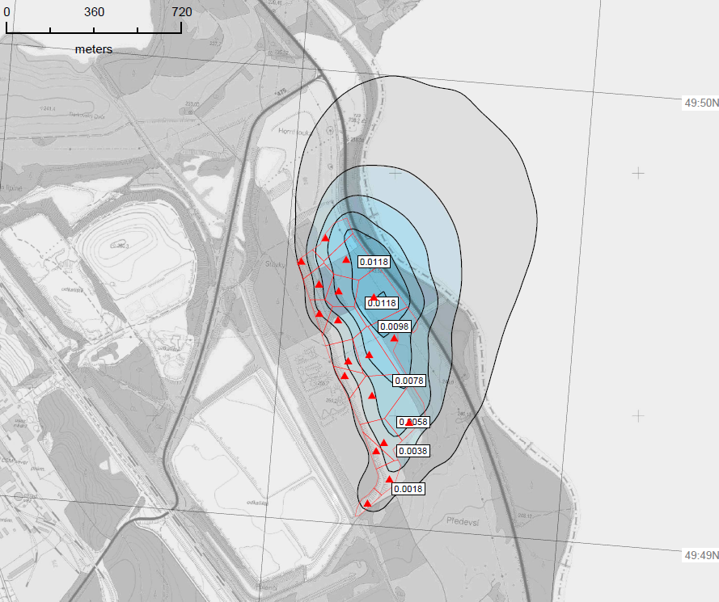
Fig. 7 ČSM Mine dump.
Total air pollution contribution to average annual concentrations of As (ng/m³)

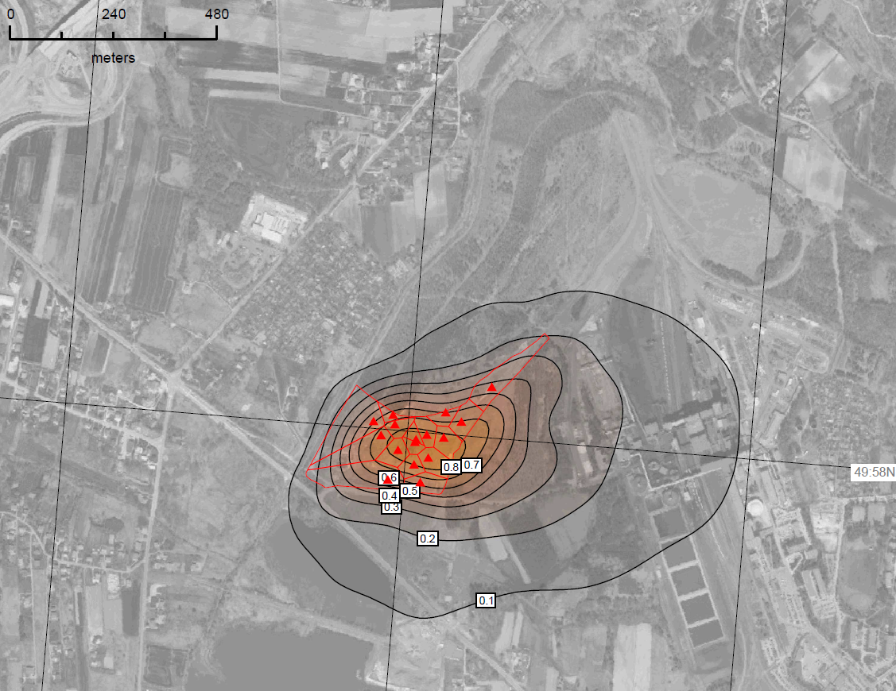
Fig. 8 Site of Szotkówka I.
Total air pollution contribution to average annual PM₁₀ concentrations (µg/m³)

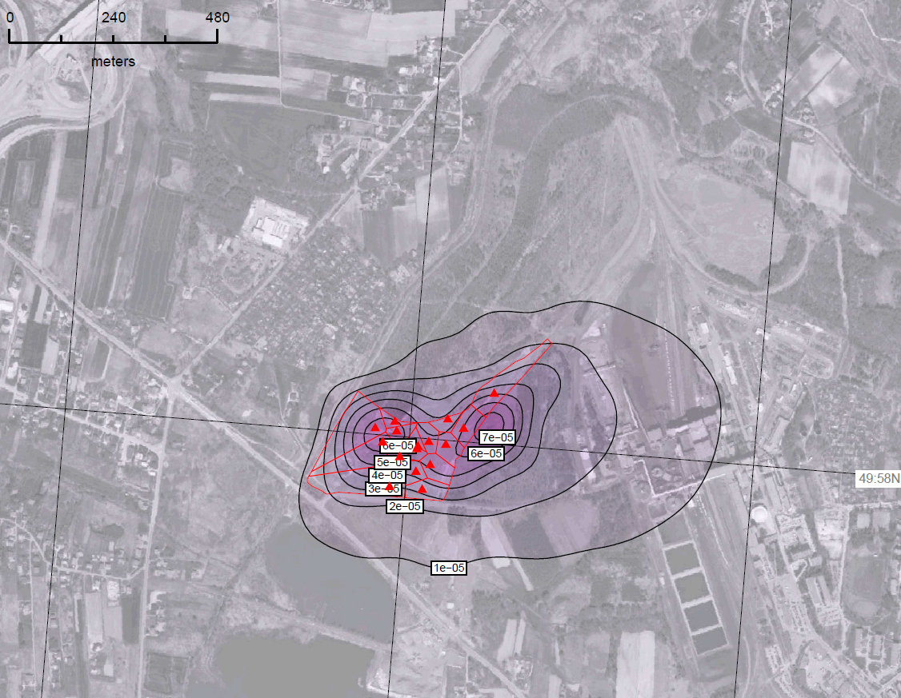
Fig. 9 Site of Szotkówka I.
Total air pollution contribution to average annual concentrations of B[a]P (ng/m³)
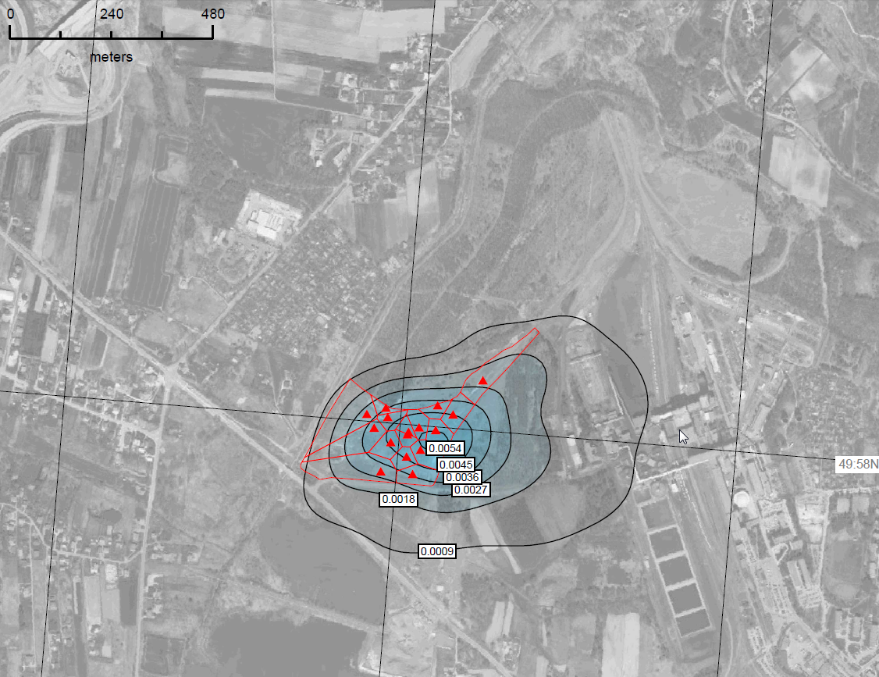
Fig. 10 Site of Szotkówka I.
Total air pollution contribution to average annual concentrations of As (ng/m³)

SUMMARY AND CONCLUSIONS
Main conclusions from modelling of PM₁₀
With regard to the overall air pollution concentration and considering the fact, that the highest impact occurs during the period of low total air pollution concentrations (windy weather with good dispersion conditions), the impact of both studied dumps on the average annual concentrations of suspended particulate matter PM₁₀ and PM_{2,5} may be considered as relatively insignificant and local (demonstrably the first hundred meters). However, the impact on the maximum daily values ​​of suspended particulate matter PM₁₀ is locally significant (potential to exceed the set limits).

Main conclusions from modelling – metals, B[a]P
The impact of both studied dumps on the annual average concentrations of arsenic and benzo(a)pyrene is irrelevant. The influence of main sources of the pollutants in the region (individual heating of family houses, transport, industry sources) is an order of magnitude greater.
Maxima of average annual air pollution contributions reach within an order of magnitude hundredths (arsenic) to ten-thousandth (benzo(a)pyrene) of the pollution limits.
Compared to the Szotkówka I dump, the ČSM dump produces significantly higher emissions, and thus even air pollution contributions of benzo(a)pyrene are apparent. However, the caused air pollution level is generally very low in an absolute value even for this dump.
The difference in the pollution contribution of arsenic at individual sites corresponds approximately to the difference of the air pollution contribution of suspended particulate matter PM₁₀ (in the case of the ČSM site, about twice the values compared to the Szotkówka I site). This is due to the similar concentrations of arsenic in the tailings surface layer on both dumps. In the case of the ČSM Mine dump, the cross-border impact on air quality is obvious in response to the immediate proximity of the state border.

Recommendations
The relatively little impact of both sites, the ČSM Mine dump and the Szotkówka I site is indeed remarkable, but it cannot be generalized for the entire region and the issues of heaps, dumps and neighbourhoods of industrial plants. This will be possible only after conducting research on all twenty sites defined in the project CZ.3.22/1.2.00/12.03398 Evaluation of concentrations of PAHs and heavy metals on the surface of dumps and nearby industrial enterprises. An important contribution of this project consists in its complexity. This is the first project, which includes most major dumps in the region, in particular on the Czech and Polish sides. Used sample locations will be so robust that based on the results obtained to assess the need for measures to mitigate impacts on air quality and define locations that require the identification of relevant regulatives
Interesting results are expected particularly in case of thermally active dumps. Furthermore, it will certainly be necessary to compare both results of each type of analyses and different modelling techniques with reference to the legislation in force in the Czech Republic and Poland.

LITERATURE
- P. Jančík a kol.: Atlas ostravského ovzduší, Vysoká škola báňská – Technická univerzita Ostrava. Ostrava. 2013.
- Matýsek D., Bielesz M. (1992): Zvětrávací procesy na haldových pokryvech OKR. Proceedings of the Conference Environment and Mineral processing, . 257-266, ed. Fečko P., Ostrava.
- Matýsek D., Raclavská H. (2003): Ověření metodiky pro hodnocení acidifikace odvalových materiálů v OKR. Uhlí-rudy-geologický průzkum. No. 4, s. 3-12.
- Kaličáková Z., Míčka V., Lach K., Danihelka P. (2013): Urban Air Pollution by Nanoparticles in Ostrava Region. Journal of Physics, Conf. Ser. 429 012005

- AZ GEO, s.r.o., Určení emisí z plošných zdrojů a fugitivních emisí vznikajících v rámci hutní a hornické činnosti, 2012
- ČSN EN 15445 Fugitivní a rozptýlené emise z průmyslových zdrojů - Vymezení zdrojů fugitivních emisí prachu metodou obráceného modelování rozptylu (RDM), 2009
- DOMBEK, V. Institute of Clean Technologies for Mining and Utilization of Raw Materials for Energy Use – a New Potential of Research in Ostrava. GeoScience Engineering, LVIII, 2, 16-22 , 2012.
- U.S. EPA, AP 42, Fifth Edition, Compilation of Air Pollutant Emission Factors, Volume 1: Stationary Point and Area Sources, Chapter 11: Mineral Products Industry, Final Section & Background document
- U.S. EPA, Improved Emission Factors For Fugitive Dust From Western Surface Coal Mining Sources - Volume I and 11, 1984
- Midwest Research Institute, Background Document for Revisions to Fine Fraction Ratios Used for AP-42 Fugitive Dust Emission Factors, 2006
- Český hydrometeorologický ústav, úsek ochrany čistoty ovzduší, podkladové materiály pro závěrečný kontrolní den projektu "Výzkum, vývoj a implementace nových měřicích metod pro hodnocení znečištění ovzduší a využití v rámci legislativy ES", VaV/740/2/02 DP 2: 2. - Zohlednění resuspenze částic ze zemského povrchu, 2003

