Numerical verification of geotechnical structure in unfavourable geological conditions – case study
Abstract: Numerical modelling represents a powerful tool not only for special geotechnical calculations in cases of complicated and difficult structure design or their foundation conditions, but also for regular tasks of structure foundation. Finite element method is the most utilized method of numerical modelling. This method was used for calculations of the retaining wall monitored during 5 years after construction. Retaining wall of the parking lot with the facing from gabion blocks was chosen for numerical model. Besides the unfavourable geological conditions, a soft nature of the facing was also a difficult part of the modelling. This paper presents the results of the modelling when exact geometry, material characteristics and construction stages were simulated. The results capture the trend of displacements even though the basic material models were utilized. The modelling proved the ability of the finite element method to model the retaining structure with sufficient accuracy as well as reasonable demand on quality and quantity of input data. This method can then be used as a regular design tool during project preparation.
Keywords: gabion wall, geotechnical monitoring, structure verification, numerical modelling
Introduction
Development of the building industry imposes increasing requirements on the space for new realized structures. Structures were done in areas with less or non-suitable geological conditions to restrict the requisition of precious areas of the country. Structures realized on these deposits have to be designed carefully with consideration of potential movements in the phase of using. Series of numerical models presented in this paper were prepared to prove the advantages of numerical modelling as an accurate method for designing of earth structures.
- Geological conditions at place of monitored structure
Terrain relief and difficult geological conditions required designing a retaining wall, leaving a sufficient area for a parking lot of new shopping centre in city of Myjava, western part of Slovakia. In the past, the area of interest was utilized as a dumping site for building waste. Complicated geological composition was determined by the occurrence of anthropogenic accumulation of large thickness containing huge amount of building waste, see profiles in Tab. 1. There was no water observed in borehole profile during the survey.
Table 1. Geological profiles in monitoring places
Monitoring profile 201-203
Depth | Thickness | Identification | Classification
0.0 – 6.9 | 6.9 | Antropogenous soil, gravely clay of firm consistency | F2 = CGY
6.9 – 7.5 | 0.7 | Weathered limestone | R4
Monitoring profile 204-206
Depth | Thickness | Identification | Classification
0.0 – 1.4 | 1.4 | Antropogenous soil, loose clayey sand | S5 = SCY
1.4 – 2.7 | 1.3 | Antropogenous soil, medium plasticity clay, stiff | F6 = CIY
2.7 – 6.0 | 3.3 | Antropogenous soil, sandy clay, firm consistency | F4 = CSY
6.0 – 10.6 | 4.6 | Antropogenous soil, high plasticity clay, firm consistency | F8 = CHY
10.6 – 11.3 | 0.7 | Weathered limestone | R4
Monitoring profile 207-209
Depth | Thickness | Identification | Classification
0.0 – 1.4 | 1.4 | Antropogenous soil, loose clayey sand | F2 = CGY
1.6 – 7.9 | 6.3 | Antropogenous soil, medium plasticity clay, stiff | F6 = CIY
7.9 – 8.5 | 0.6 | Weathered limestone | R4
There was designed the combined structure of retaining wall with gabions as facing element fixed by tensile geogrids into the embankment fill. Compaction of embankment was done by layering of fill of depth 20 cm. The gabion retaining wall was founded due to antropogenous soft soils on micropile wall reinforced at surface part by concrete beam with cross-section 1.7 × 1.0 m. This block was realized as a bond beam for two rows of micropiles embedded into stiffer subsoil. Modular gabion blocks were fabricated from double-twisted hexagonal steel mesh with openings of dimensions 8 × 10 cm. Steel is protected by the galmac and plastic coating to avoid the material corrosion. Gabion block is connected with the reinforcement made from the same steel mesh as a block. Length of the reinforcement depends on the static calculation and it was determined in the design phase using analytical methods. Gabion baskets were filled with the aggregate with fraction 100/200 mm on the construction site. (Fig. 1).
The fill was not compacted, that’s why it caused the soft facing of the wall to be more sensitive to deformations. Measurements of underground movements in horizontal plane were carried out using an inclinometric apparatus. Geodetic methods for measurements of building objects were applied for observation of surface displacements of geodetic marks according to relevant standards and nearest stabilized point [1]. Three measurement profiles were proposed for wall and embankment behaviour – 201-203, 204-206 a 207-209. Each profile was marked with three geodetic marks for surface movements measurements (Fig. 2). Profiles 204-206 and 207-209 were additionally equipped with inclinometric borehole for observation of horizontal movements (Δux, Δuy). Boreholes were marked as MY1 (6 m) and MY2 (7 m). Calibration of the numerical model was performed in the same profiles where geotechnical monitoring was realized.
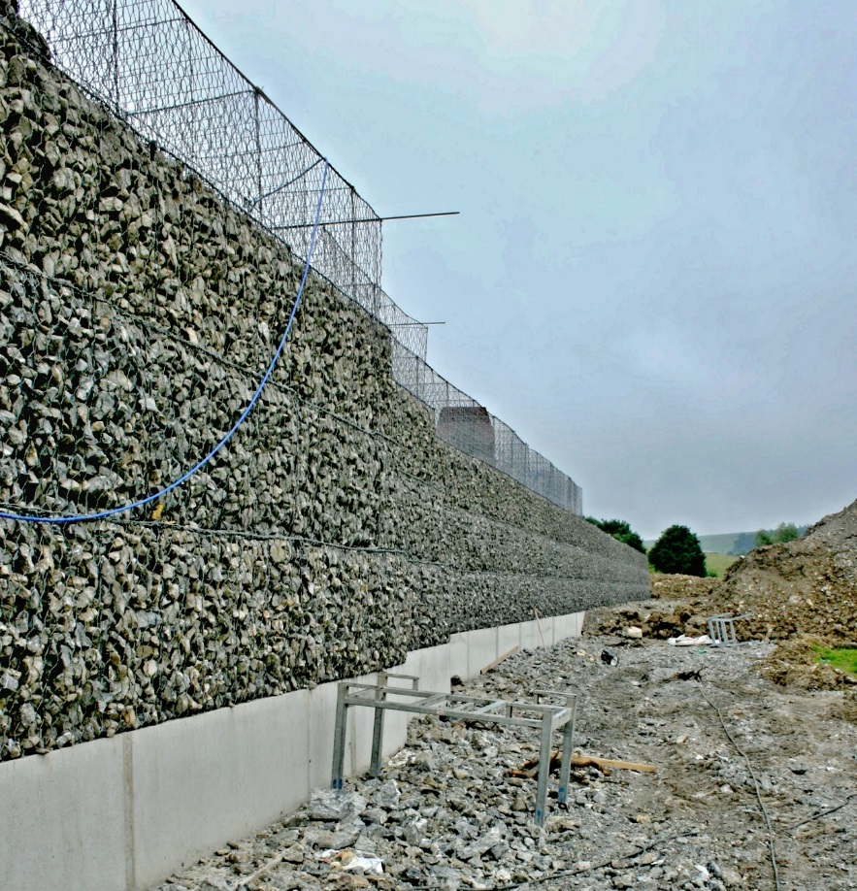
Figure 1. Construction process of gabion wall
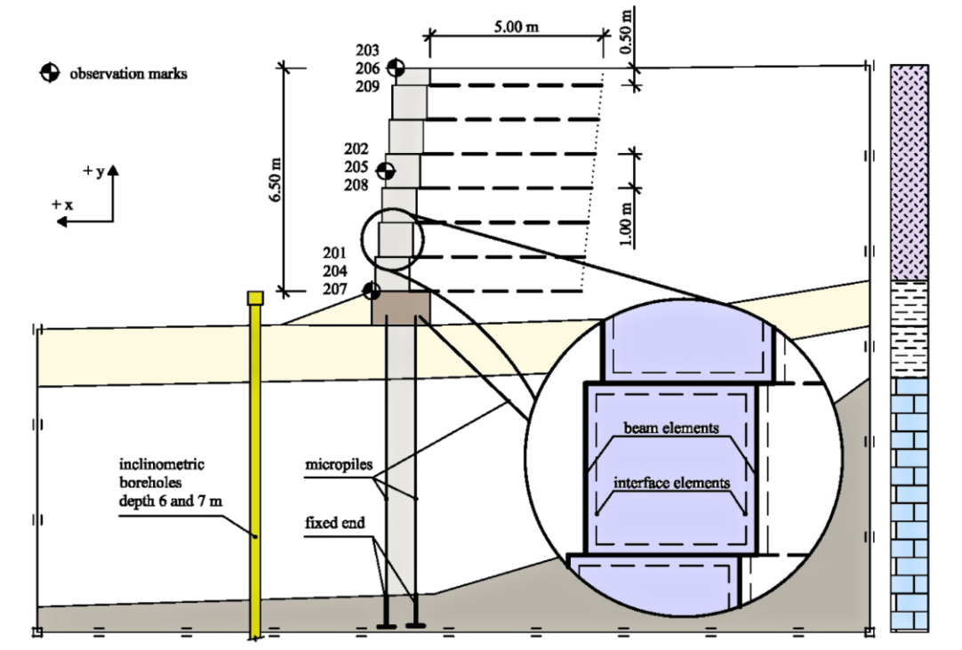
Figure 2. Scheme of the retaining wall at monitoring profile
- Numerical models
Finite element method software Plaxis 2D was deployed to create the models of monitored wall. Exact knowledge of construction phases, material and imposed load parameters served as a background for calibration of numerical models. A plain strain model with 15-noded mesh elements was used. Mohr-Coulomb model (MC) was generally chosen for soils as a robust model with less demand on input data, (Tab. 2). Linear elastic model was used for the structural elements such as micropiles, gabions and reinforcements.
Table 2. Subsoil characteristics for numerical modelling
Parameter | Soil class | S5 = SCY | F2 = CGY | F4 = CSY | F8 = CHY | R4
Parameter | FEM Model | MC | MC | MC | MC | MC
 | Conditions | Drained | Drained | Undrained | Undrained | Undrained
Unit weight | γ kN.m⁻³ | 18.5 | 19.5 | 18.5 | 20.5 | 22.5
- saturated | γ_{sat} kN.m⁻³ | 19.5 | 20.5 | 19.5 | 21.5 | 23
Permeability  - horizontal | k_{x} m/day | 10 | 1 | 0.1 | 0.001 | 0.001
- vertical | k_{y} m/day | 1 | 0.1 | 0.01 | 0.0001 | 0.0001
Young's modulus | E_{ref} kN/m² | 4×10³ | 6×10³ | 4×10³ | 2×10³ | 500×10³
Poisson's ratio | ν | 0.35 | 0.35 | 0.35 | 0.35 | 0.25
Cohesion | c kN/m² | 4 | 8 | 14 | 4 | 5 000
Angle of friction | ϕ ° | 26 | 26 | 22 | 14 | 40
Dilatancy angle | ψ ° | 0 | 0 | 0 | 0 | 7
Reduction factor | R_{inter} | 0.8 | 0.8 | 0.7 | 0.7 | 1.0

Micropiles were simulated as a beam element when only steel tube of thickness 10 mm without sealing compound was considered. End of the beam elements was fixed and simulated the fixing the micropiles into the weathered limestone. Gabions were simulated as a composite model consisting of gabion basket and gabion fill. Basket was simulated as a beam element with minimal flexural rigidity EI and without considering the unit weight of the mesh. Gabion fill was considered as a gravelled soil with smaller values of deformation characteristics such as Young's modulus and Poisson's ratio to simulate loose deposition of aggregates. There is still some level of friction between the basket and the fill although loose nature of the fill results into sliding between them [2], [3]. This effect is considered in interaction of the interface element reducing the shear strength parameters (friction angle ϕ and cohesion c). This is controlled by the reduction factor R_{inter}, which was set to 0.7. This value is recommended as a first approach to this phenomenon [2].
- Results of the modelling and the monitoring
Three observation stages were completed, including basic measurement during the three-year period. Horizontal displacements in the boreholes reach maximum values of 9 mm resp. 21 mm and fade away with increasing depth. Measurements show no significant movements below 6 m from the terrain, Fig. 3.
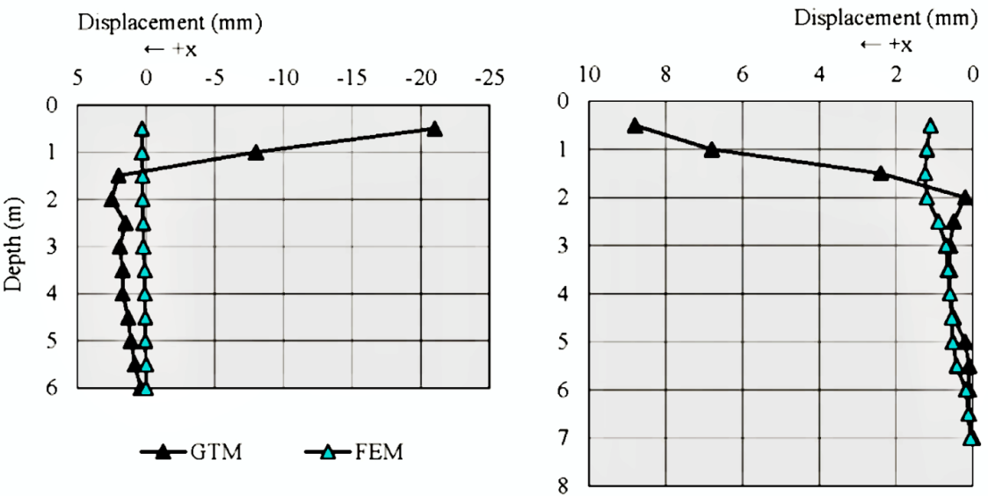
Figure 3. Maximum horizontal displacements in inclinometer MY1 (left) and
MY2 (right) and numerical model

Higher values of the displacements close under the terrain are caused by the creep deformation of the wall and climate factors such as frost penetration of anthropogenic soils.
Measurements of surface displacements display higher values than expected, which is caused by the deformation of soft facing of gabion baskets. These deformations are imposed by the influence of the load, local fall-outs of the fill grains and climate factors. The results of the modelling matched the monitoring outputs quite well in case of inclinometric measurements. It is visible that after two years of monitoring, small movements in front of the wall are still developing. Higher divergence is observed at second measurement, caused by the low temperatures during the cold winter and follow-up melting in the springtime. Climate factors are difficult to take into account, when changes of the soil properties caused by these factors need to be known. It would require additional surveys, which are not economical. Maximum deviation between monitoring and model displacements in both inclinometers reached about 1.5 mm, which can be considered as a negligible value. Moreover, the overall propagation of movements along the inclinometers is similar in both the model and the borehole, displacements fade away with increasing depth.
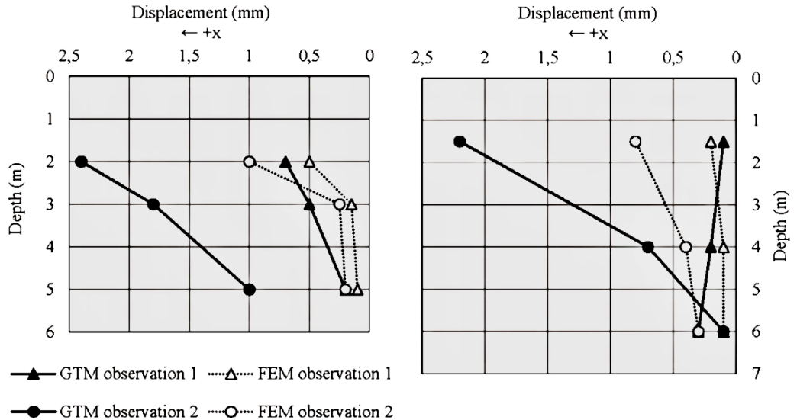
Figure 4. Time propagation of the horizontal displacements in the inclinometers MY1 (left) and MY2 (right) and in the numerical model at different places below the terrain
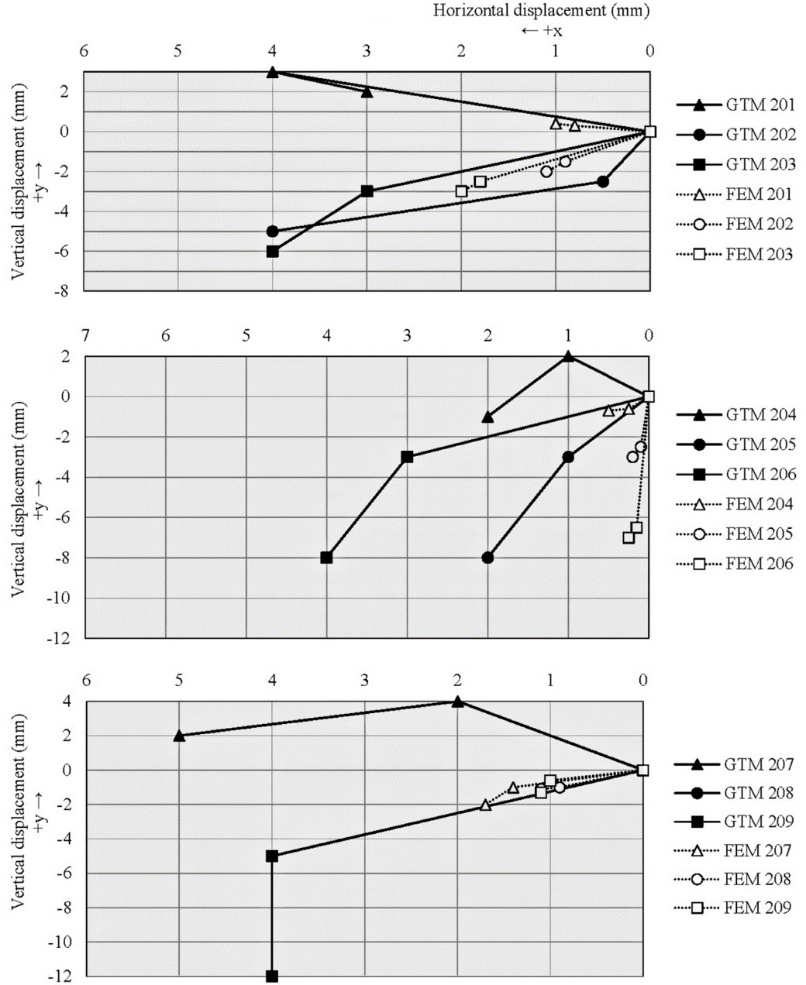
Figure 5. Time propagation of vertical (left) and horizontal (right) displacements of geodetic marks on the retaining wall and in the numerical model

Model results show more differences compared to the real measured values in case of geodetic measurements. Measured values (real data) were obtained from the geodetic measurements with the reflective marks stabilized on the face of the gabion baskets. Soft nature of the wall face is more susceptible to larger deformations, and geodetic observations confirmed that soft buckling of face of wall. The fill of the gabion baskets is not compacted enough so grains can then fall out through the mesh openings. Climate factors also influence the overall face deformations. An example of this would be rainfall, which infiltrates the open structure of the gabions and causes weathering and frost penetration of the fill. All these factors result in a larger deformation of the wall face. Certain part of the deformations has its origin in the movements of the soil body behind the gabion blocks, but exact quantification is possible only with direct monitoring of this area.
Time propagation of horizontal displacements proposed by numerical model is shown on Fig. 4. Results of measurement by geodetic method in comparison with FEM results through the time is are shown on Fig. 5.
- Conclusions
Retaining walls with gabion facings are designed in terms of earth-reinforced structures with block facing when gabions are considered as a rigid element [4], [5], [6]. In fact, gabion baskets cannot be considered as rigid, when fill is not compacted and basket is a flexible structure with some tensile strength, but with minimum flexural rigidity. Deformations of the gabions are then part of movements of the entire retaining structure. Deformations of the soil body behind the gabion block represent the second part of the overall wall displacements. Finite element method offers one of the best tools to predict the structure behaviour considering not only the strength parameters of the construction elements, but also of deformation properties.
Presented results of the modelling demonstrate the potential of even basic material models such as elastic or Mohr-Coulomb model. They are less demanding on quality and quantity of input data to predict the structure behaviour before its realization. Data can be determined using regular geotechnical methods such as in-situ testing, sounding and laboratory tests. Exact modelling of flexible facing of the retaining walls is difficult due to the uncertainties of the face behaviour and material characteristics. Overall trend of the face deformations in the model is in good agreement with the observed deformations. However, the real displacements reached larger values.
Larger deformations were caused by the climate factors during the winter, but the exact quantification of these factors is challenging.
Acknowledgment
This article came to existence thanks to support within the frame of OP Education for project "Support of quality of education and research for area of transport as an engine of economics, (ITMS: 26110230076), which is cofinanced from sources of European Social Fund.
References
AGOSTINI, R. et al. 1987. Flexible gabion structures in earth retaining works. Bologna: Officine Maccaferri S.p.A., 1987.
BS 8006-1:2010 Code of Practice for Strengthened/Reinforced Soils and Other Fills. SUBIKOVÁ M., DANDOŠ R.: Monitoring GNSS Test Base Stability (Sledování stability testovací základny pro GNSS), Geoscience Eng. 2012, Volume LVIII, Issue No.3, ISSN 1802-5420
LIN, D. G., LIN, Y. H., & YU, F. C. (2010). Deformation analyses of gabion structures. INTERPRAEVENT 2010, 512-526
DECKY, M. et al. 2013. Earth Structures of Transport Constructions. Harlow: Pearson, 2013. ISBN 978-1-78399-925-5.
MARSCHALKO, M., BEDNARIK, M., YILMAZ, I, BOUCHAL T, KUBEČKA K.: Evaluation of subsidence due to underground coal mining: an example from the Czech Republic. Bulletin of engineering geology and the environment 71 (1) 2012, pp.105-111.

