Potential Unconventional Gas Plays in Mature Basin of the Czech Republic

Petr Bujok; Martin Klempa; Petr Skupien; Dalibor Matýsek; Michal Porzer

The presence of unconventional resources has been proven in deeper parts of mature oil and gas provinces and coal basins of the World. In this context it is worth to focus also on the prospects of unconventional gas production from within hydrocarbon provinces of Moravian part of the Vienna basin. Estimation of hydrocarbon generation potential of Jurasic marls from the Mikulov Formation of the Czech part of the Vienna Basin was performed based on the Rock Eval pyrolysis.

Key words: Unconventional Resources; TOC; Palynofacies; Rock Eval; Exploration

- Introduction
Over the past decade gas from different types of unconventional reservoirs or simply natural thermogenic gas which can be produced from low-permeable organic-rich formations only by combination of stimulation techniques including hydraulic fracturing treatment and horizontal drilling has become an increasingly important source of energy.
Commercially successful production of gas from shale and tight sandstones formations is still restricted the North America. However, now the interest for targeting unconventional gas is progressively sweeping towards Europe, wherein many countries are attempting to cover gaps between steadily growing energy demand and limited supply possibilities also taking into account the ultimate aim to eliminate their dependence on imported fuels.
In the exploration of unconventional gas Poland is certainly the country which is definitively ahead of the rest of the Europe, including Ukraine or the Czech Republic. To the end of 2015 more than 54 of the prospecting wells have been drilled in Poland, while for example in Ukraine only a few. Despite its initial interest in shale gas exploration aimed at mitigation of the heavy reliance on imported NG, over the past time the Czech Republic has become skeptical about the development of unconventional resources.
Thermal maturation of organic matter (OM) in wide spectra ranging from OM dispersed in sedimentary clastics to OM concentrated in coal seams, has led to formation of an enormous unconventional gas resource in many localities throughout the world. In many cases the same stratigraphic units of kerogen-bearing rocks (shales, marls, coals) wherein gas was generated and trapped at the deeper levels because of low permeability, served at shallower levels as source rocks for conventional oil and gas. That means that we could expect presence of unconventional resources in mature oil and gas provinces and coal basins at levels deeper than the current hydrocarbon production takes place.
This paper is focused on prospects of unconventional gas production from within mature hydrocarbon provinces of Czech Republic (Moravian part of the Vienna basin).

- Unconventional gas from the point of view of the Czech Republic

2.1 Geologic structure of the Czech part of Vienna Basin
Almost all conventional hydrocarbon deposits of the Czech Republic are confined to the Moravian part of the highly prolific Vienna basin, where the earliest drilling operations started in 1900. The Vienna Basin is definitively one of the most important oil and gas provinces in Europe containing at least 46 fields in its Austrian part (Wessely, 1999) and at least 20 oil-bearing structures and gas-producing horizons in the Czech and Slovak parts.
The basin is associated with a classical thin-skinned pull-apart basin of Miocene age, which sedimentary fill is overlying the Carpathian thrust belt (Wessely, 1999; Decker, 1996). Deep autochthonous basement in this area comprises Precambrian crystalline and Paleozoic-Mesozoic sedimentary units of the North European Platform (Adámek, 2005).
Pre-Miocene basin floor is heterogenic. It consists of allochthonous nappes sheets emplaced onto autochthonous pre-folding sequences resting on the pre-Mesozoic basement. The formation of the Vienna Basin fault system is dated by the onset of subsidence in the Vienna Basin in Miocene, which opened as a transtensional pull-apart between two left-stepping segments of the fault zone (Fig. 1), which was later compressionally inverted in the Pliocene.
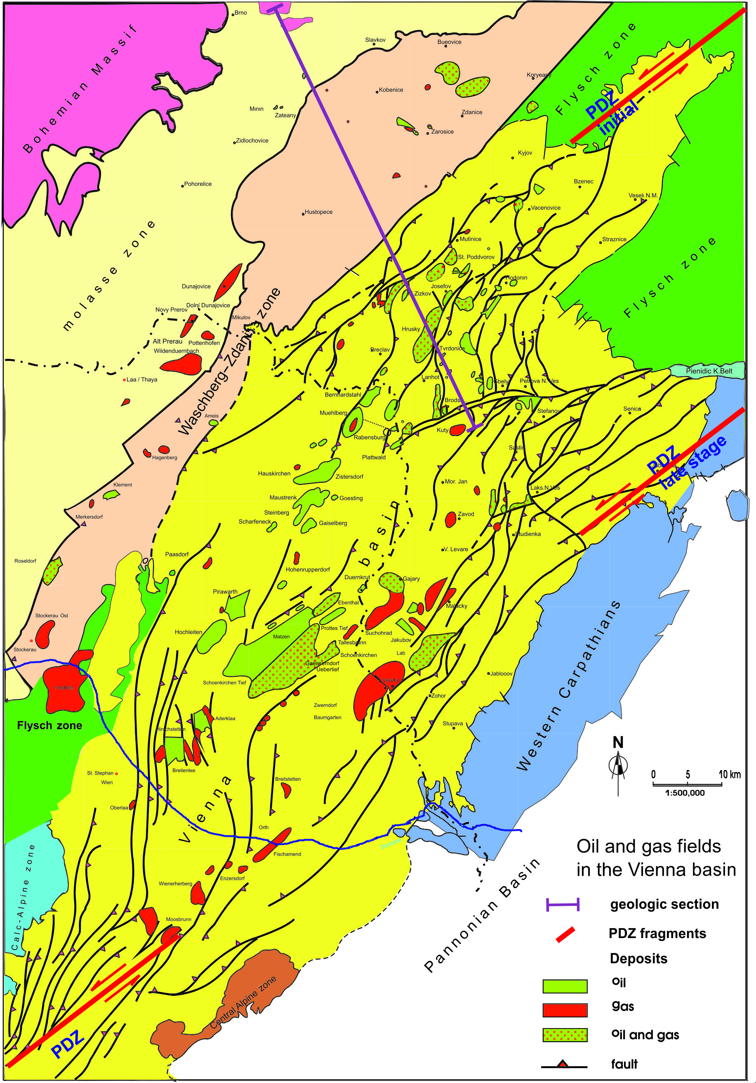

Fig. 1. Oil and gas fields in the Vienna basin (modified after Arzmuller et al., 2006; fragments of principal displacement zone PDZ are from Wu et al., 2009)

In fact deposition in the basin and formation of the Central Moravian depression from our point of view have been largely controlled by strike-slip reactivations within fragments of the principal displacement zone PDZ (Fig. 1) in the Pre-Miocene basement floor (Wu et al., 2009). Recent active strike-slip faulting is kinematically linked to the reactivation of major Miocene normal faults branching off from the wrench fault in the central part of the Vienna Basin (Hinsch et al., 2005). Modern stresses and focal mechanisms from earthquakes along the Vienna Basin mostly indicate sinistral strike-slip faulting along north-east striking subvertical faults. However, 3-D interpretation of seismic sections within the Central Moravian Depression and, more specifically, mapping of paleochannels in the Mid Miocene Badenian sediments did not show significant lateral offsets of across such big faults as the Steinberg fault. It can be interpreted whether as a prove of absence of playing a significant role of strike-slip tectonics since the Late Badenian (Prochác et al., 2012; Drusa et al., 2015; Sidorova, 2001; Šofranko et al., 2014) or alternatively as an evidence of multiple sign-variable sinistral-dextal reactivation of faults with almost zero total displacement.
The petroleum systems of the Vienna basin Miocene sedimentary carapace and entire the Carpathian region in Moravia are mostly associated with the Jurassic source rocks and only partially with Paleogene source rocks (Picha and Peters, 1998). However, taking into account our special interest to unconventional resource plays (Bujok et al., 2012; Klempa et al., 2013) we focused on the subthrust zone which includes autochthonous the Upper Jurassic Mikulov Formation. It represented by organic-rich Malmian dark marls which are considered to be qualified as world-class source rock (Krejčí et al., 1996; Picha and Peters, 1998; Golonka and Picha, 2006). Previous geochemical studies (Ladwein, 1988, Franců et al. 1996, Pícha and Peters 1998; Schulz et al., 2010; Sapinska-Sliwa et al., 2016) demonstrated that organic matter of the Mikulov marls is composed of a kerogen type II -III with total organic carbon TOC in range of 0.2-10 %. According to Krejčí et al. (1996), the reactive part of kerogenin Mikulov marls is type II, while the abundant inertinite makes the bulk hydrogen index lower.
Oils and gases generated within formation supplied several oil and gas fields in the Miocene reservoirs mostly laterally via several major fault and fracture zones and episodically vertically through locally released domains in the thrust belt during discrete episodes of trans tension reactivations of the PDZ. The Mikulov Formation is buried under the flysch units of shaly lithology and these together with heavily faulted base of the Carpathian thrust belt have served as some kind of regional seal restricting an active vertical migration of gaseous hydrocarbons from deep generation levels.

  - Generation potential of the Mikulov Formation marls
Estimation of hydrocarbon generation potential of Jurasic marls from the Mikulov Formation of the Czech part of the Vienna basin were performed based on the Rock Eval pyrolysis results (Labus and Bujok, 2013) for 7 core samples from depth in range from 3173 m to 4551 m, with the following direct measurements of parameters S1 (amount of volatilized free hydrocarbons - mg/g of rock), S2 (amount of latent hydrocarbons released from kerogen during gradual heating - mg/g of rock), S3 (amount of CO₂ relieved from organic matter in mg/g of rock), Tmax (temperature - °C, at which maximum release of hydrocarbons occurs at the top of the S2 peak). Initial parameters were normalized to TOC (total organic carbon - g) to give the hydrogen index HI = 100*S2/TOC and oxygen index OI = 100*S3/TOC, both -mg/g of rock.
The derived generation potential S2, hydrogen index HI and oxygen index OI values were used to qualify more precisely kerogen types. Analysis of obtained data (Fig. 2) within the plot of Rock-Eval generation potential S2 versus total organic carbon (TOC) and the plot of oxygen index (OI) versus hydrogen index (H)I demonstrates that studied samples can be determined as a mixture of kerogens of types II (oil-prone organic matter from marine plankton) and III (gas-prone terrestrial organic matter from higher plants).
Measured concentrations of organic matter TOC for our dataset are generally considered as good values to serve as effective source rocks (6 samples are showing range 1.02-1.34 %; average 1.14 %), however these values are in range of fair for shale gas exploration and do not fit with criteria identified for successful shale gas plays in the USA (more than 2% TOC).

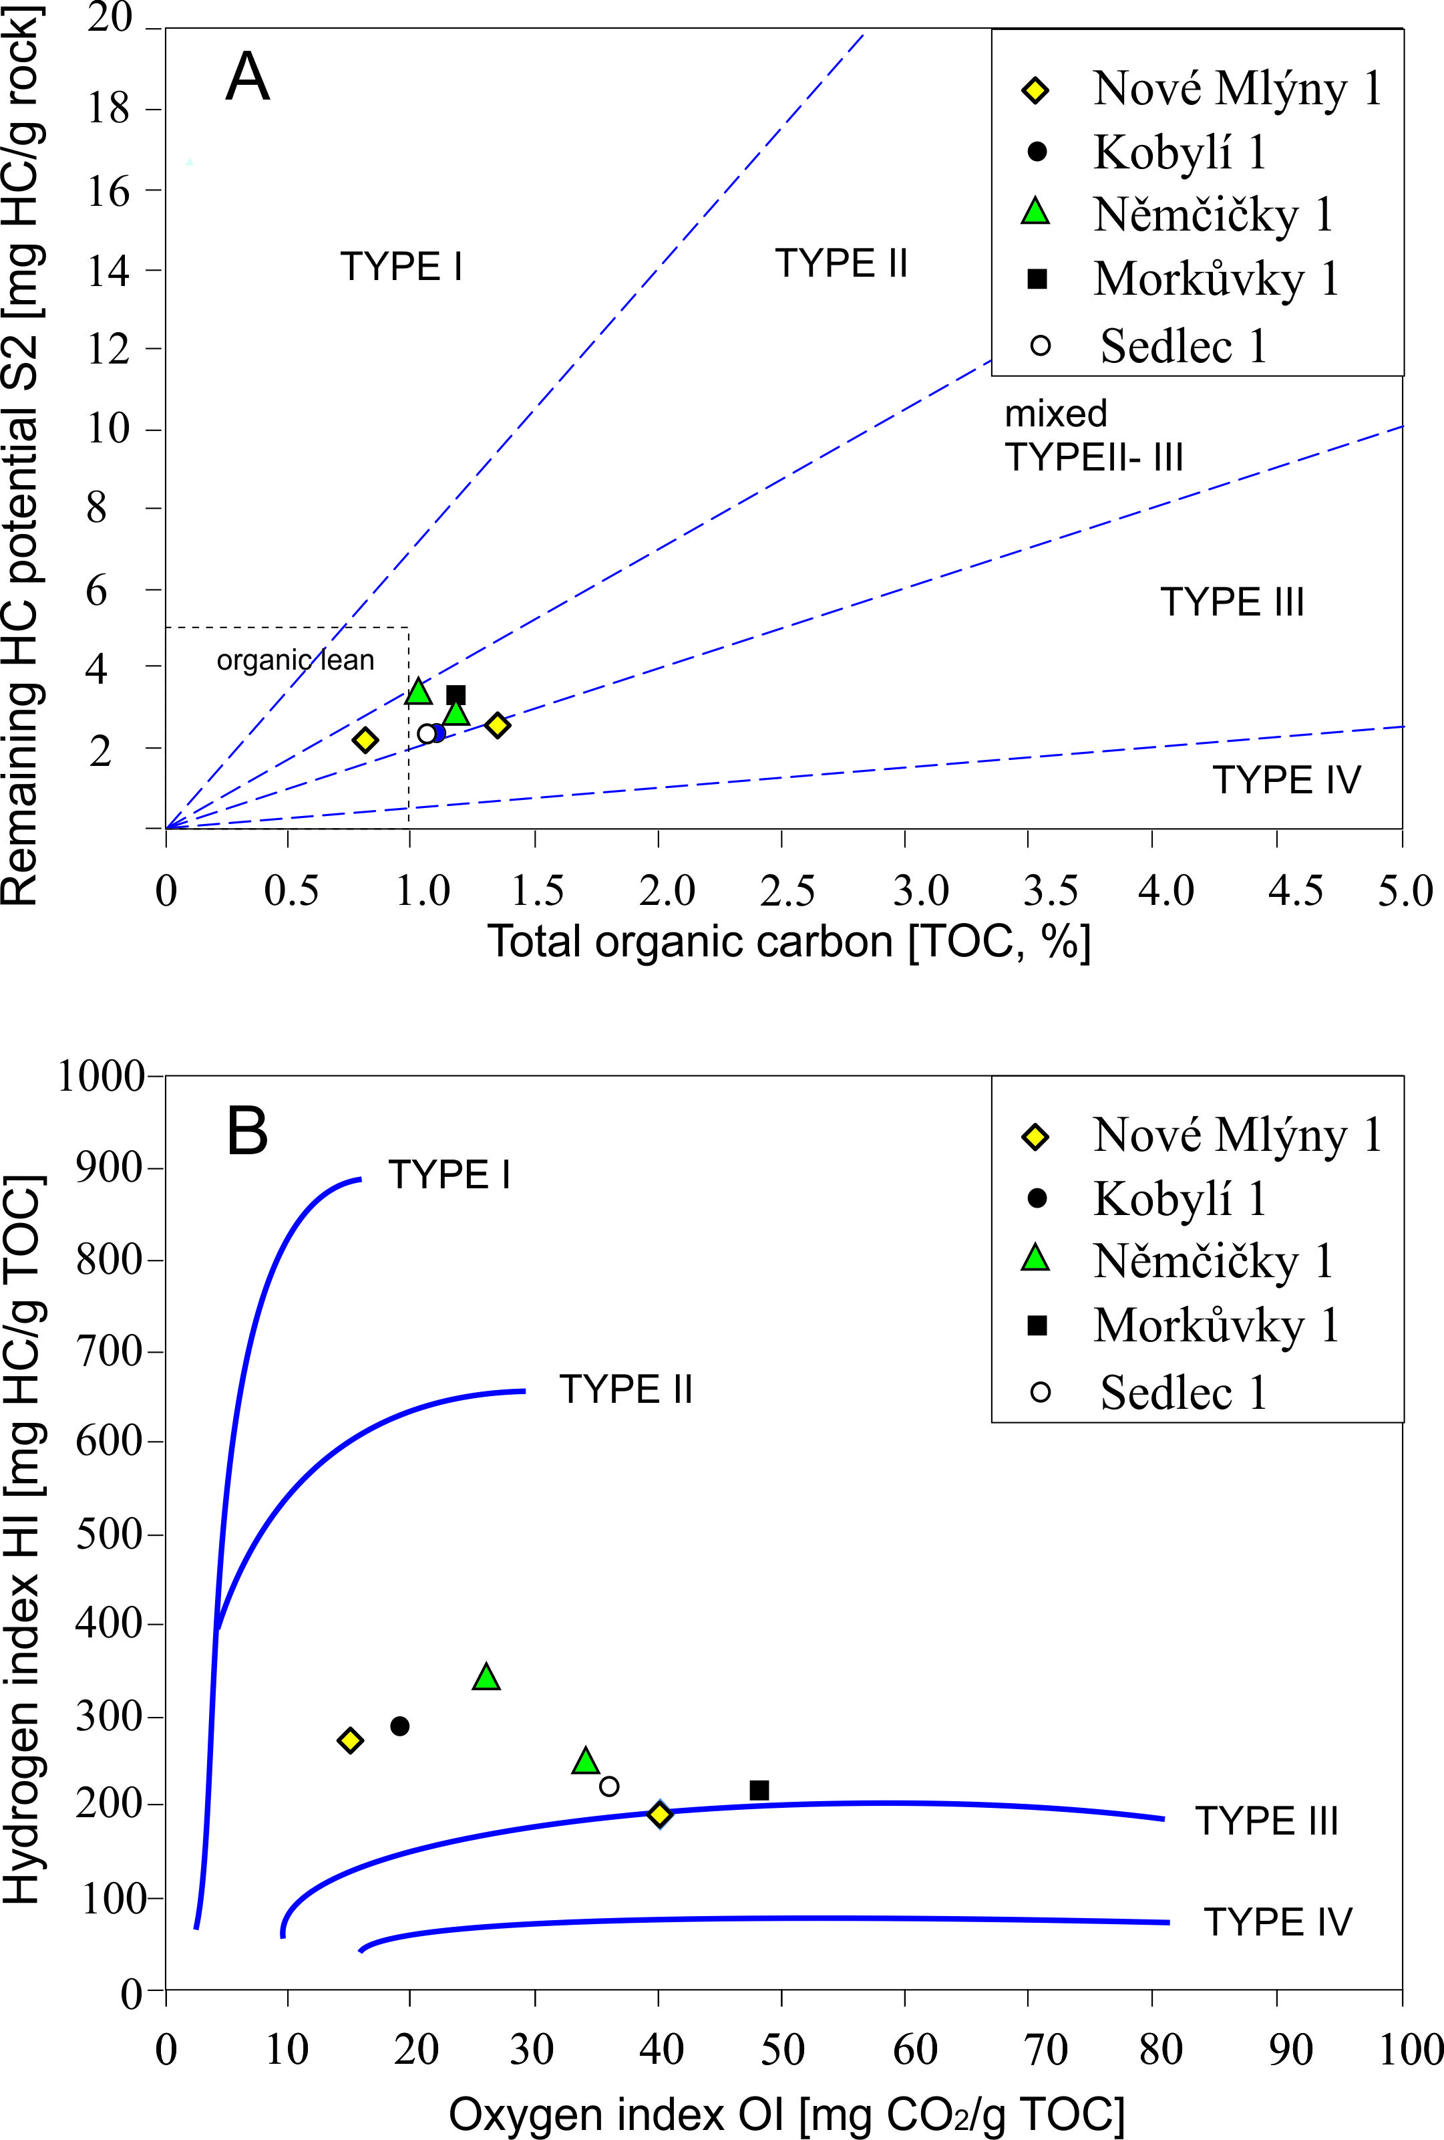

Fig. 2. Plot of Rock-Eval generation potential S2 vs. total organic carbon TOC (A) and plot of oxygen index OI versus hydrogen index HI (B). Based on the data by Labus and Bujok (2013).

The presence of mixed kerogen of II-III types also have confirmed by palynofacies analysis (Fig. 3, 4) and numerous documentations of remains of terrestrial organic matter in grains of vitrinite and inertinite (Fig. 5). The presence of inertinite is important geological record, because it indicates at least oxidation due to atmospheric exposure for Mikulov Formation during deposition.

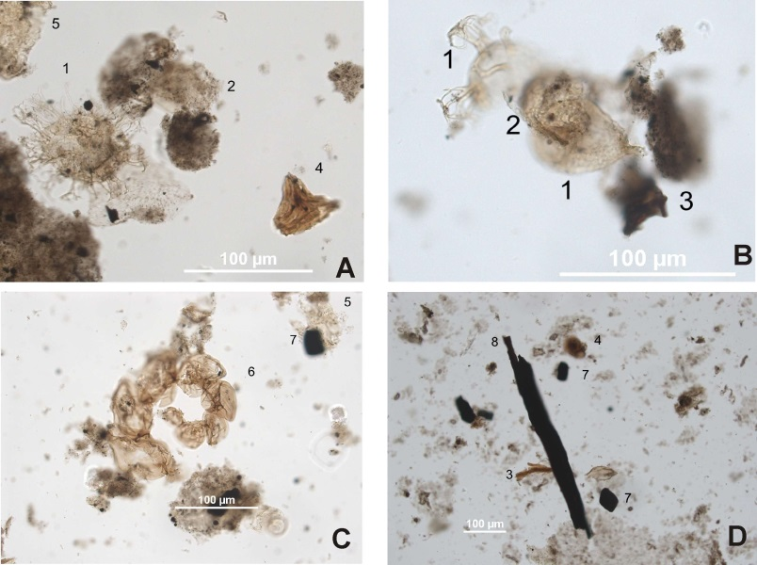

Fig. 3.Palynofacies of samples from wells Sedlec 1, NovéMlýny 1 and Kobylí 1
A – palynofacies of sample Sedlec; B – palynofacies of sample NovéMlýny; C, D – palynofacies of sample Kobylí; details: 1 – dinoflagellstae, 2 – algae, 3 – brown particles, 4 – spore, 5 – cuticle, 6 – forameniferal assemblage, 7 – amorphous black particle, 8 – sharp-edged black particle.

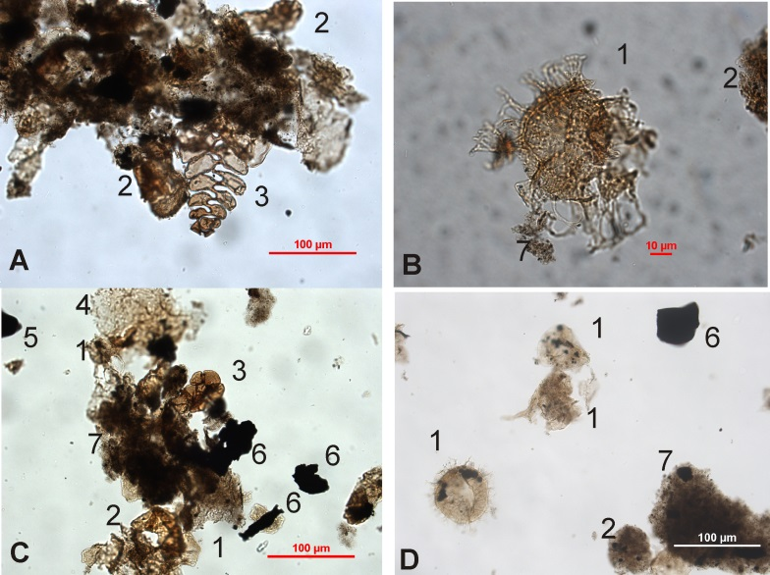

Fig. 4.Palynofacies of samples from wells Němčičky 1, Morkuvky 1
A, B – palynofacies of sample Němčičky; A – algae assemblage and algogenic organic matter , B – cyst of dinoflagellatae; C, D – palynofacies of sample Morkuvky; details: 1 – dinoflagellatae, 2 – algae, 3 – forameniferal assemblage, 4 – cuticle, 5 –spherical black particle, 6 – sharp-edged black particle, 7 – algogenic organic matter

For 6 samples the vitrinite reflectance 𝑅𝑜 have been measured by using of oil-immersion objective of Microscope Photometer TIDAS MSP 200 in point scan regime.
Hydrogen index (HI) plotted against Tmax for samples (Fig. 5) illustrates that studied samples are from Type II/III kerogen with HI ranging from 193 to 346 mgHC/gTOC and these are already allocated in the oil window.
For shale gas exploration it is critically important to obtain estimations of depth of zones for liquid and gaseous hydrocarbons generation.
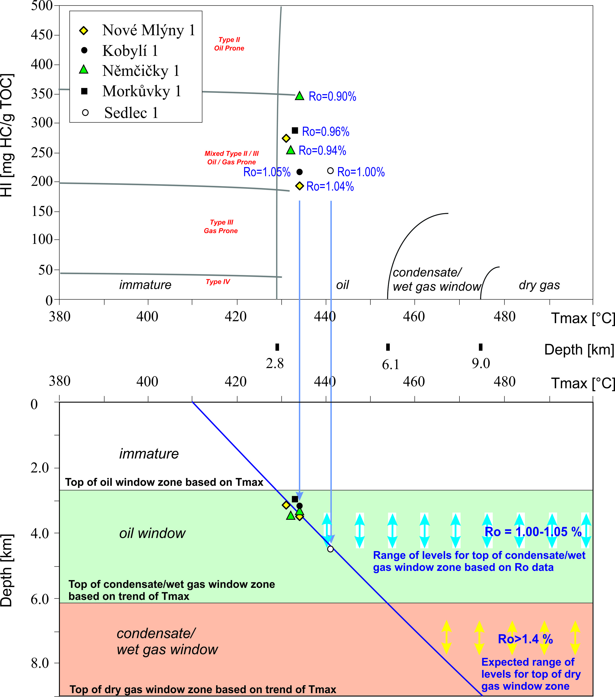

Fig. 5. Plot of hydrogen index HI vs. maturation Rock-Eval parameter Tmax for samples and depth distribution of zones associated with oil, condensate/wet gas, dry gas windows based on Tmax values and trends and alternatively based on measured vitrinite reflectance values. HI and T_{max} data from Labus and Bujok, (2013)

Our attempts to delineate mature section based on maturity parameter Tmax suggesting that top of the zone of condensate / wet gases generation zone is allocated at the level of 6.1 km and the top of dry gas zone is allocated at depth of 9.0 km. However, there is a clear misfit between 𝑅𝑜 and Tmax values. In comparison with maturity based on measured vitrinite reflectance 𝑅𝑜 our dataset shows anomalously low Tmax values even within acceptable TOC and S2 parameters. It could be because of impregnating sampled marls in situ by migrated oil or just resulting from the presence of oil-based mud additives within samples (Peters, Moldowan 1993). Taking into account the level of maturity based on measured vitrinite reflectance data we can expect the significant uplift of the top levels of wet gases/ condensate and dry gas zones. Trend of 𝑅𝑜 suggests that condensate / wet gases generation is occurring at a depth of 3.5-4.5 km and we can expect dry gas generation onset at a depth of approximately 7.0 km.
In the northwest–southeast-trending Dyje–Thaya depression, which was formed during the Jurassic rifting (Picha et al., 2006), a set of subthrust antiformal structures, e.g. Tynec, Holic, and Lednice, have been delineated on seismic data with depths to the tops of these structures in range from 4000 m (Lednice antiform) to 6000–7000 m (Tynec and Holicantiforms) and these are already in condensate-gas window. These structures were formed as tilted blocks and horsts during the Jurassic rifting with further reactivation as local restraining bends during the strike-slip faulting.
At such depths fractured marls of Mikulov Formation may be overpressured because of sedimentary loading and recent tectonic stresses. One of the reasons to consider this option is the fact that this pelitic-carbonaticunit at the deep levels is tectonically enlarged (Adámek, 2005) by multiple duplications. Such kind of structural thickening related with thrust cleavage duplexes occur in the Marcellus Shale (Pashin, 2009), which is up to now the most successful exploration reservoir for commercial shale gas production. These duplexes are interpreted as manifestations of the progressive transfer of slip from floor to roof through a disturbed zone that serves as a shear boundary between large, more internally passive, thrust sheets (Cook and Thomas, 2010). In case of the Vienna basin tectonically thickened weak pelitic-carbonatic marls of Mikulov Formation could serve as the accommodation rock volume for development of ductile deformations associated with intensive folding and faulting in the overlying competent layers of allochtonous structural flour. Ductile duplexes and associated thrust-related subhorizontal fracturing related with abnormal fluid pressure (Hathaway and Gayer, 1996) now are widely recognized as positive signal for targeting productive shale gas reservoirs (Pashin, 2009; Cook and Thomas, 2010).
Fractured intervals with gas kicks in the Mikulov Formations have been observed at great depths (7.5 km scale) in Austrian part of the Vienna basin (Wessely 1990). We suppose that this fracturing could be resulted from the same mechanism of formation of compressional duplexes and gives hopes for good potential of preservation here the subthrust levels of the basin significant unconventional gas resource in deep overpressured compartment.

- Conclusions
The presence of unconventional resources has been proven in deeper parts of mature oil and gas provinces and coal basins of the World. In this context it is worth to focus also on the prospects of unconventional gas production from within hydrocarbon provinces of Moravian part of the Vienna basin. Estimation of hydrocarbon generation potential of Jurasic marls from the Mikulov Formation of the Czech part of the Vienna basin was performed based on the Rock Eval pyrolysis. Average TOC concentration reached 1.14 % - a good value to serve as effective source rocks, this however does do not fit with the criteria used in the USA for successful shale gas plays.
Maturity level of based on vitrinite reflectance indicates significant uplift of the top levels of wet gases/ condensate and dry gas zones. The trend suggests that condensate / wet gases generation is occurring at a depth of 3.5-4.5 km and dry gas generation onset could be expected at a depth of approx. 7.0 km.
Compared for example with Ukraine, in the Donets Basin, source rocks are located probably in the Devonian and Lower Carboniferous section of the basin fill. Lowermost Upper Viséan rocks or Rudov Beds are several tens of meters thick and contain in average 5% TOC. The organic matter is interpreted as type III-II kerogen. A single total gaseous hydrocarbon system encompassing the entire sedimentary succession has been identified in the Donets Basin. Taking into account the unique concentration of proven reserves in the order of 60 Gt for workable coal seams at exploitable depth, and, more specifically, tremendous mass of mostly originated from terrestrial plants dispersed organic matter (in range of 1 to 6 Tt), appropriate gas-generation window thermodynamic conditions over most of the basin area, we can conclude that this is a serious prospect of targeting one of the biggest unconventional basin-centered gas deposits within the Donets Basin.

Acknowledgement
This article was written in connection with project Institute of clean technologies for mining and utilization of raw materials for energy use - Sustainability program. Identification code: LO1406. Project is supported by the National Programme for Sustainability I (2013-2020) financed by the state budget of the Czech Republic.

References

- Adámek, J. (2005): The Jurassic floor of the Bohemian Massif in Moravia – Geology and paleogeography. Bulletin of Geosciences, volume 80, issue 4, pages 291 – 305. ISSN: 12141119.
- Arzmüller, G.; Buchta, Š.; Ralbovský, E.; Wessely, G. (2006): The Vienna basin. In: Golonka, J.; Picha, F. J. (eds): The Carpathians and their Foreland: Geology and Hydrocarbon Resources. AAPG Memoir 84, pages 191 - 204. Belokon, V.G., 1975. Deep structure of the Donbas (in Russian). Geol. Journal. 5, 11-27.
- Bujok, P.; Skupien, P.; Klempa, M.; Labus, K.; Třasoň, T.; Zeman, V. (2012): Břidlicový plyn, současnost a perspektivy možné těžby /Shale gas: the present and future prospects of potential exploitation. Uhlí, rudy, geologický průzkum, ZSDNP volume 19, 2/2012, pages 3-7. ISSN: 1210-7697.
- Cook, B.S.; Thomas W. A. (2010): Ductile duplexes as potential natural gas plays: an example from the Appalachian thrust belt in Georgia, USA. Geological Society, London, Special Publications, volume 348, pages 57-70. ISSN: 03058719.
- Decker, K. (1996): Miocene tectonics at the Alpine-Carpathian junction and the evolution of the Vienna Basin. Mitt. Ges. Geol. Bergbaustud. Oesterr, volume 41, pages 33-44.
- Drusa, M.; Vlček, J.; Bulko, R.; Kais, L. (2015): The importance of proper evaluation of the geological conditions for the design of industrial floor subbase. Geoscience Engineering, volume 61, issue 2. ISSN 1802-5420.
- Franců, J.; Radke, M.; Schaefer, R. G.; Poelchau, H. S.; Čáslavský, J.; Boháček Z. (1996): Oil-oil and oil-source rock correlations in the northern Vienna basin and adjacent Carpathian Flysch zone (Czech and Slovak area), in G. Wessely and W. Liebl, (eds.), Oil and gas in Alpidic thrust belts and basins of Central and Eastern Europe: Geological Society (London) Special Publication 5, p. 343–353
- Golonka, J.; Picha, F. (eds), (2006): The Carpathians and their foreland: Geology and hydro car bon resources. The American Association of Petroleum Geologists. Tulsa, 84: 1–600.
- Hathaway, T. M.; Gayer, R. A. (1996): Thrust-related permeability in the South Wales Coalfield. Coalbed Methane and Coal Geology, Geological Society, London, Special Publications, volume 109, pages 121-132.
- Hinsch, R.; Decker, K.; Wagreich, M. (2005): 3-D mapping of segmented active faults in the southern Vienna Basin. Quaternary Science Reviews, volume 24, issue 3-4 spec iss., pages 321-336. ISSN: 02773791.
- Klempa, M.; Porzer, M.; Bujok, P.; Pavluš, J. (2013): Research on petrophysical properties of chosen samples from the point of view of possible CO₂ sequestration. Geoscience Engineering, volume 59, issue 4. ISSN 1802-5420.
- Krejčí, O.; Franců, J.; Poelchau, H.S.; Müller, P.; Stráník, Z. (1996): Tectonic evolution and oil and gas generation at the bor der of the North European Platform. In: Wessely, G. & Liebl, W. (eds), Oil and Gas in Alpine Thrustbelts and Basins of Central and Eastern Europe. EAGE Special Publication, 5: 177–186.
- Labus K., Bujok P. (2013): Properties of Mikulov marls as potential unconventional gas source rock in the Czech part of Vienna Basin. Annales Societatis Geologorum Poloniae.
- Ladwein H. W. (1988): Organic Geochemistry of Vienna Basin: Model for Hydrocarbon Generationin Overthrust Belts. American Association of Petroleum Geologist Bulletin, volume 72, issue 5, pages 586–599. ISSN: 01491423.
- Pashin, J. C. (2009): Shale gas plays of the southern Appalachian thrust belt. Tuscaloosa, Alabama, University of Alabama, College of Continuing Studies. International Coalbed & Shale Gas Symposium Proceedings, paper 0907, 14 p.
- Peters, K. E.; Moldowan, J. M. (1993): The Biomarker Guide: interpreting molecular fossils in petroleum and ancient sediments. Prentice Hall, Englewood Cliffs, NJ, 363 pages. ISBN: 0130867527.
- Picha, F. J.; Stráník, Z.; Krejčí, O. (2006): Geology and hydrocarbon resources of the Outer Western Carpathians and their foreland, Czech Republic. in J. Golonka and F. J. Picha, eds., The Carpathians and their foreland: Geology and hydrocarbon resources: AAPG Memoir 84, pages 49 – 175.
- Picha, F. J.; Peters, K. E. (1998): Biomarker oil-to-source rock correlation in the Western Carpathians and their foreland, Czech Republic. Petroleum Geoscience, issue 4, pages 289–302.
- Prochác, R.; Pereszlényi, M.; Sopková, B. (2012): Tectono-sedimentary features in 3D seismic data from the Moravian part of the Vienna Basin. First Break, volume 30, issue 4, pages 49 – 56. ISSN: 02635046.
- Sapinska-Sliwa, A.; Rosen, M. A.; Gonet, A.; Sliwa, T. (2016): Deep borehole exchangers – a conceptual and comparative rewiev. International Journal of Air-Conditioning and Refrigeration, volume 24, issue 1. ISSN 20101325.
- Schulz, H.-M.; Horsfield, B.; Sachsenhofer, R. F. (2010): Shale gas in Europe: A regional overview and current research activities. Petroleum Geology Conference proceedings, series 2010, volume 7, issue 1, pages 1079-1085. ISSN: 20479921.
- Sidorová, M. (2001): Formation damage effects in a horizontal wells completion. Acta Montanistica Slovaca, volume 6, special issue, pages 23 – 26. ISSN 1335-1788.
- Šofranko, M.; Škvareková, E.; Wittenberger, G. (2014): Working fluids used for drilling deep boreholes. Applied Mechanics and Materials, volume 508, pages 150 – 155. ISSN 16609336.
- Wessely, G. (1990): Geological results of deep exploration in the Vienna basin. GeologischeRundschau, volume 79, issue 2, pages 513-520. ISSN: 00167835.
- Wu, J. E.; McClay, K.; Whitehouse, P.; Dooley, T. (2009): 4D analogue modelling of transtensional pull-apart basins. Marine and Petroleum Geology, volume 26, issue 8, pages 1608–1623. ISSN: 02648172.

